
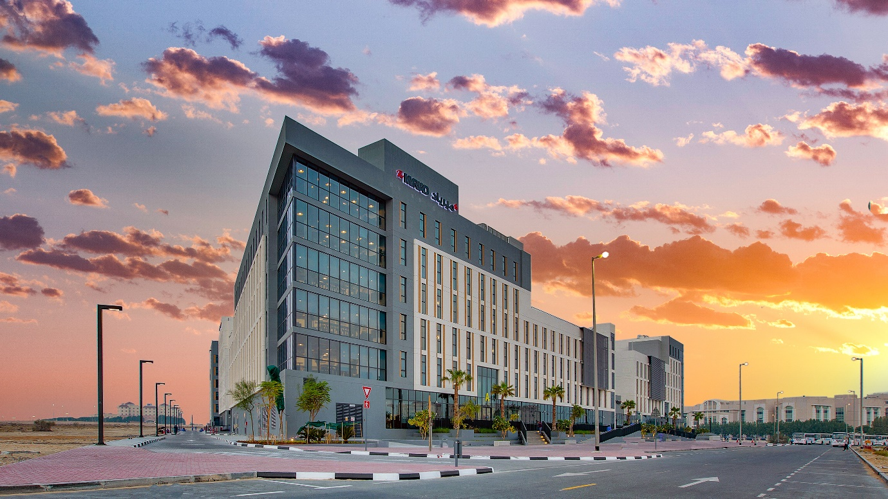

Room Reservation Confirmation

Thank you for choosing The Myriad Dubai. We look forward to welcoming you.
Your booking confirmation number is TMD-3761BD6F.
To confirm this reservation, please make the deposit in the following bank account using the above reference number within the next 3 days or get in touch with us directly on the below mentioned contact details, in case you wish to pay by credit card, and our team will send you a payment link accordingly. Failure to pay the deposit will result in a cancelled booking.
Please note that The Tenant may terminate the Tenancy Contract (accepted upon acknowledging Terms & Conditions and Code of Conduct) within fourteen (14) days of the booking confirmation date prior to check-in, without penalty, and any amounts paid in advance, including the Deposit, will be refunded in full, without set off or deduction. The cancellation charges will not apply and the full amount of the Deposit will be refunded via bank transfer within 21 to 25 business days, given that accurate banking information is provided by the resident.
This cancellation policy will not apply if the booking was confirmed in less than fourteen (14) days prior to the start date of the Tenancy Contract, the Tenant further agrees that terms and conditions of the Tenancy Contract will apply.
Cancellation charges will apply, if the Tenant terminates the Tenancy Contract after fourteen (14) days of booking confirmation made, and the Tenant agrees to pay a penalty of one (1) month Rent for long term stays exceeding one (1) month, and seven (7) days Rent for short term stays under one (1) month booked on a daily rate.
If Tenant fails to occupy the Room on the Tenancy Start Date and within seven (7) days of the Tenancy Start Date, fails to inform the Landlord of any delay in their occupation, this will be classified as a “no show” and the terms and conditions of the Tenancy Contract will still apply and remain in full force and effect. The Tenant will be charged the relevant early termination penalties, as applicable.
Kindly note that arrival and departure timings apply for all residents on ‘daily rate’ short term stays under one (1) month. The check-in time at The Myriad Dubai is from 11:00 onwards and the check-out time is before and no later than 18:00. For early arrivals or late departures, an additional night, at the daily rate of the selected room type, will apply.
We have 24x7 staff available at the property, to facilitate post-midnight check-ins.
If you have already paid your deposit, your room is confirmed and will be ready. Please note that special requests, room, and/or roommate sharing preferences are always subject to availability, therefore not guaranteed.
Kindly keep ready of the following documents UPON CHECK-IN.
• Original Passport
• University enrolment letter
• Payment Receipt copy (if applicable)
• Underage residents must be accompanied by their guardian, or written consent needs to be presented by the resident upon check-in along with a copy of the guardian ID.
Here is our location map link: The Myriad Dubai Location Map
Please see the header image of the property for your reference.
Please feel free to browse through our FAQs that cover most topics frequently asked by our new joiners, as well as our Pre-Arrival Guide to help you prepare for your arrival to Dubai and your new student living community.
Click the following link to see the BUS SCHEDULE, and many other useful information for our residents: https://linktr.ee/TMDResidents
You are most welcome to also WhatsApp us on +971 800 697423 for any further queries and we would be happy to assist!
We're excited to have you join The Myriad Family as one of our proud Myrians!
Your reservation details are:

ROOM | DETAILS
STUDIO ROOM | ALEX
 | kelner.alexandra@gmail.com
 | +971551004354

COMMITMENT | CHECK IN | CHECK OUT
MONTHLY | 01-Sep-2024 | 30-Sep-2024

PAYMENT |  | BANK DETAILS
Rent (Pay at property) | AED 6,400 x 1 | Bank: Commercial Bank of Dubai
Payable deposit now | AED 2,500 | Branch: 70 - CBD Al Islami - Main Branch
 |  | Title: Student Housing Operations FZ-LLC
 |  | Account #: 1007836750
 |  | Currency: AED
 |  | IBAN: AE830230000001007836750
 |  | Swift Code: CBDUAEAD

For any further information  leasing@dxb.themyriad.com  800MYRIAD (697423) |  |  |  |  | 

© 2023 The Myriad. All Rights Reserved.  A Member of Strategic Housing Group | Visit our website: TheMyriad.com

Important Reminder: Please confirm the exact duration of your stay during check-in as you will be required to sign your tenancy contract digitally. Once the contract is signed, it is considered final and cannot be altered. The check-in and check-out dates in the contract must match precisely. Any additional stay days beyond this agreement will result in charges at a daily rate, requiring the signing of a new contract. Please refer to the TENANCY CONTRACT TERMS & CONDITIONS - Click here: Terms and Conditions @ The Myriad
Furthermore, please notify us of any changes in your check-in date prior to your arrival so that your booking can be updated accordingly and to avoid possible cancellation. Your arrival date should align with the specified check-in date of this reservation.

